Contents

Introduction 1

Create an HDInsight cluster 1

# Introduction

The purpose of this demo is go through the portal and create an HDInsight cluster.

# Create an HDInsight cluster

Ensure that your service administrator has subscribed to the HDInsight preview.

Click on the HDInsight tab on the left and select **Create a new Cluster** from the results pane. We can fill in the necessary details on the

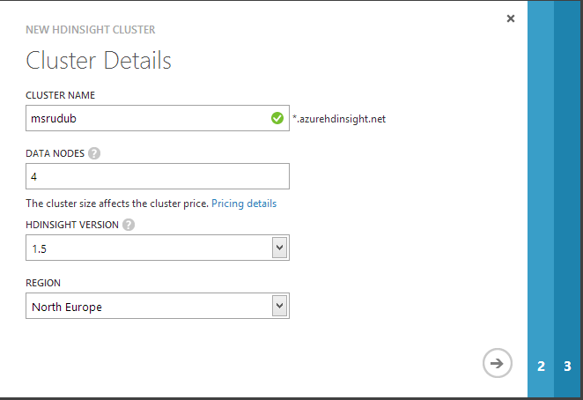

Proceed the second step of the wizard.

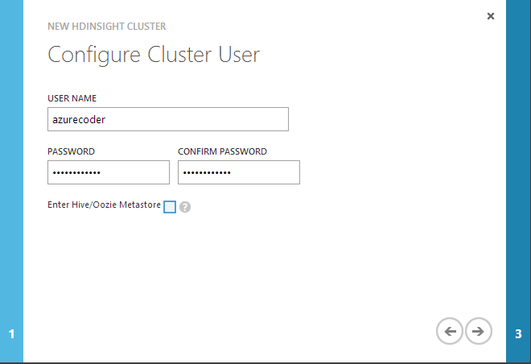

Confirm this and enter the details for the storage account which will be used for ASV.

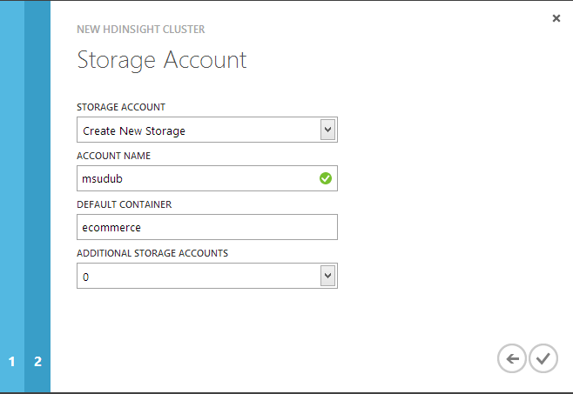

You should see some feedback through the portal showing the feedback.

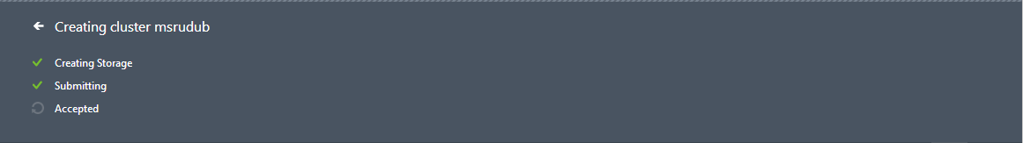

When the cluster creation is complete you can click on it to see details of remote desktop and other things.

When the cluster is deployed you should be able to press the manage cluster button.

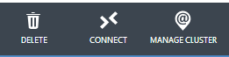

This exposes the HDInsight portal.

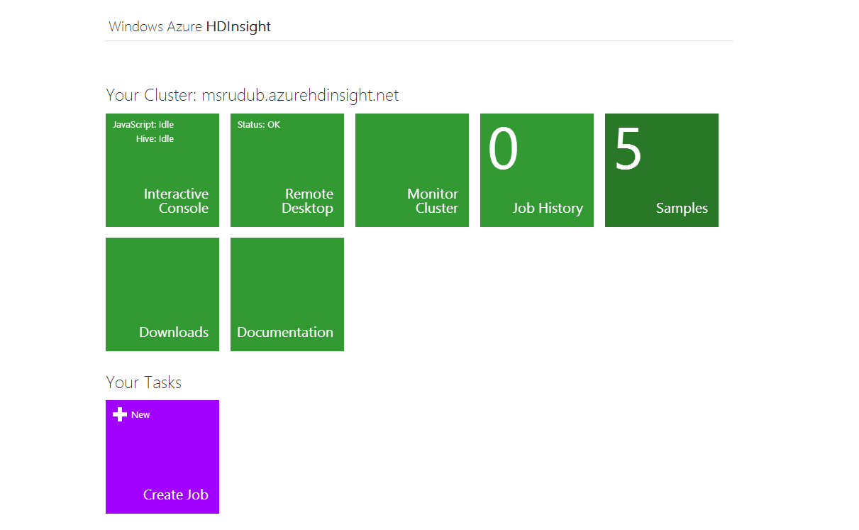

We should be able to remote desktop into the head node now. We’ll leave that session open.